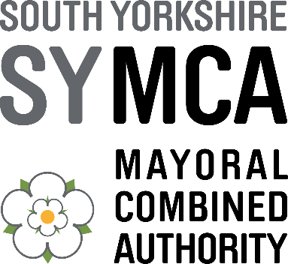

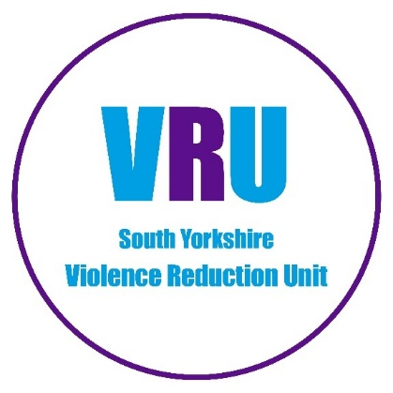

VIOLENCE REDUCTION UNIT (VRU) GRANTS SCHEME

GUIDANCE NOTES
2026-27

Issue: | 3
Date: | May 2026

- INTRODUCTION

The Violence Reduction Unit (VRU) Grants Scheme has been in operation for over 7 years. During this period, the VRU has awarded over £2.9 million in grants to non-profit organisations in South Yorkshire from its own budget.

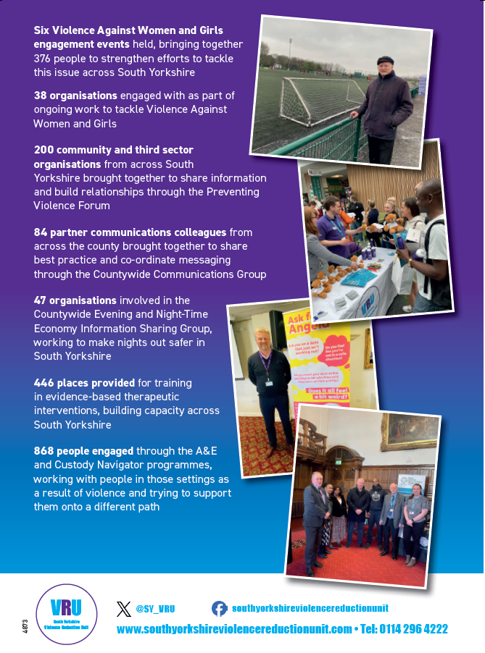
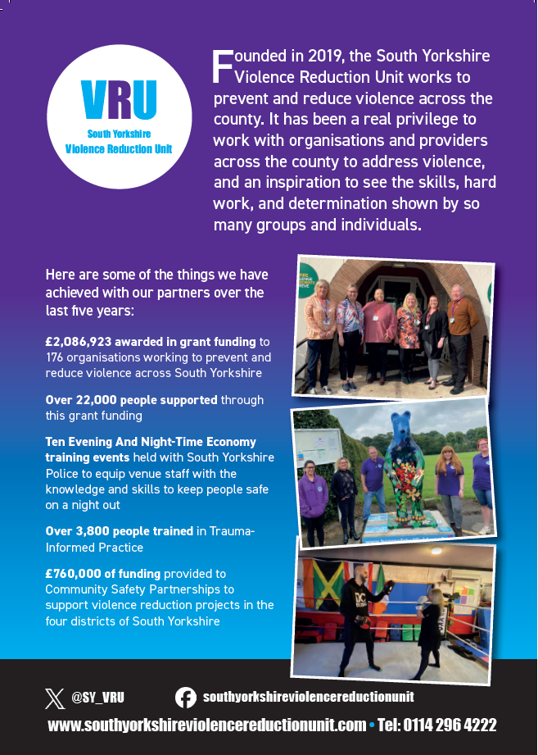

- FUNDING AIM

The VRU has an overall vision “To empower and enable people in the communities of South Yorkshire to work together and embrace opportunities for preventing and reducing violence” and has identified 16 priorities to achieve this:

- Work with partners to promote safe, nurturing, and stable relationships between children and their parents and caregivers
- Encourage all professionals and organisations to become trauma-informed, to an approved standard for South Yorkshire
- Tackle domestic abuse and work to ensure that survivors can access the support they need
- Promote gender equality to reduce and prevent violence against women and girls
- Work in partnership to improve South Yorkshire residents’ mental health, and work so that those who need support receive it in a timely manner
- Support people who misuse substances to make more positive choices
- Work in partnership to reduce the harmful use of alcohol
- Work in partnership to ensure that children and young people have equal opportunities to access education and that their different starting points and situations are taken into account
- Support people into employment and provide pathways to further education and retraining
- Promote the importance of access to adequate housing for people to help them stay healthy and thrive
- Increase community cohesion, supporting residents to identify and maximise their assets
- Support effective rehabilitation, providing ways out for those already entrenched in violence, or who have previously been in prison
- Reduce access to lethal means
- Work to change the cultural and social attitudes which contribute to violence
- Work to embed the Public Health approach in Community Safety Partnerships, and ensure that existing mechanisms for change are fully utilised
- Reduce violence through victim identification, care, and support programmes

The Community Grants Scheme directly contributes to these areas of focus by enabling non-profit organisations to deliver community-based projects aimed at keeping people safe, tackling crime and anti-social behaviour, and supporting victims of crime. Grant funding this year will be awarded to organisations whose applications fall within at least one of the following five key themes:

- Reducing / Preventing Knife Crime
- Reducing Violence Against Women and Girls, targeted at those under 25.
- Coaching and Mentoring to Reduce Violence
- Diversionary activities away from violent crime
- Reducing / Addressing Racial disproportionality in Serious Youth Violence

- FUNDING AVAILABLE

Supported by a mix of VRU and South Yorkshire Mayoral Combined Authority (SYMCA) funding, non-profit organisations can apply for up to £20,000 to deliver projects lasting up to 12 months (between 1st October 2026 – 30th September 2027).

We award grants of varying sizes based on the scale and scope of the project proposed. There is no lower limit for grant awards. The exact funding amounts awarded to successful applicants are determined following assessment by the grants panel.

Payment of the grant funding will be in four instalments, as follows:

Payment | Percentage | Requirements
1 | 25% of grant total | Completion and return of contract documentation
2 | 25% of grant total | Satisfactory assessment of monitoring
3 | 25% of grant total | Satisfactory assessment of monitoring
4 | 25% of grant total | Satisfactory assessment of final monitoring

We reserve the right to release further payments only when spend has been demonstrated and it exceeds or is close to exceeding the last payment received.

We reserve the right to offer alternative payment terms which will be recorded in the grant agreement.

- ELIGIBILITY INFORMATION

WHO WE FUND
The scheme is eligible to non-profit making organisations delivering projects and activities to benefit local people and communities in South Yorkshire. These include:

- Registered charities
- Voluntary organisations with a clear not-for-profit purpose in their governing document
- Unregistered community groups that comply with our governance arrangements
- Community Interest Companies limited by guarantee
- Schools and trusts (delivering non-statutory activities additional to the National Curriculum and standard school day)

We do not fund NHS bodies, prisons, or local government bodies, including councils at all levels. We do not fund businesses or profit-making enterprises.

All organisations must have the following governance arrangements in place:

Requirement | Details
An established Governing Body i.e. Board of Trustees or Directors | - Must have a minimum of 3 members including 1 independent member*  - Must meet at regular points throughout the year
A Governing Document i.e. constitution, memorandum of articles, trust deeds, etc. | This governing document must clearly state:  - Organisation is not for profit and has a clear purpose and/or objectives  - Dissolution clause/asset lock in place in the instance of closure
Financial management arrangements | - Bank account in organisation’s name  - Financial transactions and payments must be reviewed by 2 unrelated payment authorisers
Safeguarding policy and procedures | - Up-to-date policy in the applicant organisation’s own name with effective implementation and monitoring arrangements  - Appropriate, regular training arrangements for staff and volunteers  - All staff and volunteers with direct access to children, young people and vulnerable adults subject to DBS background checks  - Clear steps in the event of an incident or concern  - Named safeguarding representative within the organisation
Adequate insurance levels | - Employers Liability  - Public Liability  - Professional Indemnity (where applicable to the project proposed)
*‘Independent’ is defined as governing members who are not related to each other or living together.

WHAT WE FUND
We recognise the important role that voluntary and community sector organisations play in developing and delivering local solutions to local issues. The VRU Community Grants scheme invites organisations to apply for funding to support at least one of our 5 key theme areas:

- Reducing / Preventing Knife Crime
- Reducing Violence Against Women and Girls, targeted at those under 25.
- Coaching and Mentoring to Reduce Violence
- Diversionary activities away from violent crime
- Racial Disproportionality in Serious Youth Violence

The funding can be used to establish new activities, to build on existing provision or to trial something completely new as a pilot project. We are especially interested in funding imaginative and innovative projects that offer new ways of meeting and addressing the VRU’s priorities.

Proposals can be targeted towards supporting specific groups or communities and/or addressing local issues. All applications should be developed in response to an identified or unmet need which can be backed up with evidence. Applicants should also engage with other local providers to ensure the project is integrated into the wider local offer.

WHERE WE WOULD WELCOME INTERVENTIONS

The Violence Reduction Unit (VRU) considers a range of factors when assessing applications. These may include whether proposed activities are in areas identified as higher risk—based on local and national data—as well as alignment with Community Safety Partnership priorities.

While delivery in specific areas is not a prerequisite for successful funding, the VRU would particularly welcome projects and interventions delivered in the following areas:

Sheffield

Sheffield Central
Wicker
Page Hall
Batemoor & Jordanthorpe
Burngreave & Grimesthorpe
Firth Park
Norfolk Park
Woodthorpe
Herdings & Gleadless Valley
Hillsborough
Woodhouse
Stradbroke
Rural wards (including Stocksbridge, Upper Don, Stannington and Mosborough)
East and West Ecclesfield (noting limited existing provision for young people)
Abbeydale Road/Sharrow

Suggested activity focus:
- Targeted detached youth work
- Early intervention and prevention activity linked with schools and local communities
- Engagement with young people at risk of involvement in violence or ASB
- Creative and diversionary provision (e.g. music, arts and drama-based activity) to engage those less likely to access traditional services

Rotherham

Rotherham Central
Eastwood
Masbrough & Bradgate
East Herringthorpe
Eastwood & East Dene
Thrybergh & Hooton Roberts
Rawmarsh South

Barnsley

Barnsley Central
Worsbrough Common
Hoyland

Suggested activity focus:
- Outreach activities / detached youth work
- Street based preventative worker akin to a “Street Navigator” – targeting children involved in drug use and engaging them at street level and supporting them into support.
- Engagement at street level to reduce prevalence of violence within the town centre

Doncaster

Doncaster Central & Hyde Park
Hexthorpe & Balby North
Balby Carr
Bentley & Toll Bar
Conisborough & Denaby
Scawthorpe
Dunscroft

Suggested activity focus:
- Detached youth work

Projects operating within these locations are encouraged, as they align closely with current strategic priorities.

SCHEME PRIORITIES
The VRU Community Grants Scheme provides funding for projects that directly contribute to the areas of focus detailed in our priorities listed above.

The VRU has 16 priority areas of focus, and all applicants should select at least ONE priority area of focus from the list for their application to be admissible. More than one can be selected.

TYPES OF PROJECTS FUNDED
We recognise that different target groups, communities and issues require different approaches and activities to meet their unique and varying needs. As such, we support a wide range of different projects and initiatives. The following provides an overview of the types of projects we fund:

Preventing
- Activities to divert children and young people away from crime such as sports, arts, music, media, technology, youth work, social action and environmental/gardening
- Training and education programmes to equip participants the skills and knowledge to manage their behaviours, make better choices and feel safer in their communities
- Activities designed to change behaviours, reduce risk factors, and break down barriers

Supporting
- Targeted interventions to support vulnerable and/or disadvantaged groups such as care leavers, victims of crime, LGBTQIA+, Black and Minority Ethnic Groups and those residing in areas of high deprivation
- Mentoring and peer support projects to engage young people and vulnerable young adults identified as needing additional or alternative support
- Projects aimed at supporting and assisting victims of crime and groups identified as vulnerable or at risk

Responding
- Awareness raising and education programmes exploring issues identified in the VRUs priorities
- Social action projects designed to bring local people together to address local priorities and needs

This list is by no means exhaustive. We welcome organisations to propose new ideas and approaches when applying.

EXCLUSIONS

Governance/Management
- Organisations who have failed to return monitoring for a previous VRU Community Grant Scheme.
- The project lead is already named as the lead on another VRU Community Grant.
- Organisations that fail to demonstrate that they have a South Yorkshire presence/focus and cannot evidence that they have taken steps towards building relationships and/or establishing the delivery arrangements.

Financial
- Websites, publications, or seminars, unless part of a wider proposal.
- General fundraising appeals, requests for donations and other non-specific funding requests.
- Capital and building costs including renovation, conversion, costs for fixed equipment (boilers, lights, etc.) and vehicles. Low value equipment costs essential to delivery may be considered as part of a wider project.

Operational
- Activities or events taking place outside of South Yorkshire including visits and trips.
- Projects that should be delivered using other public funding sources or are a statutory duty of another organisation e.g., street lighting, road repairs, traffic calming.
- CCTV
- Projects that duplicate services already commissioned by the VRU, SYMCA or other funding organisations.

Other
- Activities intended to influence or attempt to influence Parliament, government, or political parties.
- Activities that attempt to influence awarding or renewal of contracts and grants, or legislative or regulatory action.
- Organisations that promote a particular religion or political movement or only provide services to people of that religion or political leaning.
- Proposals that have been previously assessed and declined, unless expressly invited to make changes and reapply.
- Recipients are not permitted to charge, apply fees or require payment for any activity provided in connection with VRU funding.
- Recipients shall not make a profit from any VRU funding.

- THE APPLICATION PROCESS

WHEN TO APPLY
The Grants Panel will meet according to the deadlines detailed below. Applicants will receive notification of the panel’s decision approximately 2-4 weeks after the deadline. Please note the dates below when planning the project.

Application Deadline | Panel Meeting | Provisional Notification | Project Start Date | Project End Date
Friday 26th June Noon | Mid July | Mid August | 1st October 2026 | 30th September 2027

HOW TO APPLY
The grant documentation, including the guidance notes and application form, are available online at

https://southyorkshireviolencereductionunit.com/violence-reduction-fund-2026/

We require applicants to submit their application via email using the application form from our website. All applications must be sent by email to Grants@southyorkshire-ca.gov.uk or by post to:

South Yorkshire Violence Reduction Unit
11 Broad Street West, Sheffield, S1 2BQ

The Grants@southyorkshire-ca.gov.uk mailbox is set for automatic responses, if you do not receive an auto response to your application submission, please contact the team on SYVRU@southyorkshire-ca.gov.uk.

The VRU will accept no more than one application bid per organisation.

Applicants are advised to read this document in full alongside the Application Form Guidance Notes 2026 prior to submission of an application. In addition, we recommend you attend the ‘Come and Find Out More’ workshop scheduled for June 3rd 2026, please register here Community Grant Workshop by midday June 2nd.

THE APPLICATION FORM
Please carefully read and refer back to these guidance notes when completing your grant application. We hope that you will find the application process straightforward but please email Grants@southyorkshire-ca.gov.uk should you have any questions about the application process. Anonymised questions and their responses will be published every Thursday on the VRU website.

To enable the Grants Panel to make an informed decision, we need you to provide us with a detailed proposal that describes your project clearly and concisely. Please do not assume that the panel possesses any prior knowledge of your organisation and the activities you are proposing. The panel is unable to accept any attachments to your submitted application and can only review one application per organisation.

When drafting your proposal, try to consider and cover the key questions of who, when, why, what and how. We would also advise you to think carefully about the impact and changes that you are hoping to achieve by delivering this project.
Applicants should answer all questions and must adhere to the word limit stipulated for each question.

The information contained in your application will form the basis of the Grant Funding Agreement. It is therefore important that the information you provide in your application is accurate, realistic and achievable.

Applicants will be asked to provide the following information:

- Organisation details  - Details of previous VRU / SYMCA / OPCCC awards  - Delivery experience and objectives  - Details of delivery location  - Contribution to the VRU Priorities  - Project summary  - Project description including participant numbers | - Explanation and evidence of need  - Partnership arrangements  - Monitoring measures and arrangements  - Anticipated project impact  - Exit / Continuity plan for when the funding ends  - Financial information i.e. project budget  - Declarations (Due Diligence & Authorisations)

EVIDENCING NEED
Data can help organisations to better understand local issues, to allocate their resources where demand is the greatest and to evidence the need for their activities. The following links to different data sources may be helpful when developing an application:

Data Owner | Data Type
South Yorkshire Police | Crime on a map
Government | English indices of deprivation 2025 - GOV.UK
Government | Statistics: exclusions - GOV.UK (www.gov.uk)
Public Health England Fingertips | Health Data
Barnsley Metropolitan Borough Council | Ward profiles, Microsoft Power BI
Barnsley Metropolitan Borough Council | Joint Strategic Needs Assessment (JSNA), CORE - Barnsley 2030: PowerPoint presentation template
Team Doncaster (Local Authority) | Community Profiles and Demographics
Team Doncaster (Local Authority) | Joint Strategic Needs Assessment
Rotherham Metropolitan Borough Council | Ward Profiles – Rotherham Metropolitan Borough Council
Rotherham Metropolitan Borough Council | PowerPoint Presentation  PowerPoint Presentation
Sheffield City Council | Ward profiles
Sheffield City Council | Joint Strategic Needs Assessment

PREPARING YOUR BUDGET
Applicants are required to prepare an itemised budget as part of the application process. It should provide a clear breakdown of how the project costs have been calculated and offer value for money.

The budget will be initially assessed as part of the essential criteria. Applications whereby the budget does not meet the essential criteria detailed below will not progress to the assessment panel.

We would encourage applicants to review their budget against the following points before submitting their application:

Budget Checklist | Ticklist
Do all lines in the budget add up and balance?
Is the budget broken down into separate lines for the key items of funding?
Have you shown your working out and/or justified your proposed budget where necessary i.e. how you have arrived at the total figure?
Ensure that any trips are clearly explained and fall within the budget guidance for funding
Has the budget been checked and agreed by your Financial Monitoring Officer?
Have you checked the budget against the VRU Community Grant Scheme: Expenditure Guidance (Page 10) to ensure all items are eligible to receive funding?
Does your project budget offer value for money?
Have you kept a copy of the budget, ideally in Microsoft Excel, for your records to refer back to?

Please refer to the guidance below when preparing your budget to understand the level of detail required from your budget:

Budget Section | Items to include: | Examples
Funding from other sources (Cash & match) | - Name of funder  - Funding scheme (where applicable)  - Amount  - Type of funding i.e. cash or match  - Status i.e. agreed, submitted pending decision, not confirmed | - Sheffield City Council (Community Safety Fund) - £5,000 Agreed  - National Lottery (Awards for All) - £10,000 Submitted pending decision
Employee | - Job title  - Purpose e.g. deliver sports session  - Hourly rate/salary rate  - Number of hours per session  - Total number of sessions  - Total amount being requested | - Sports coach to facilitate sessions:  £13 per hour x 1.5 hours per session x 2 sessions per week x 20 weeks = £780  - Caseworker to support participants:  £25,000 per annum + 12% oncosts (£28,125) x 0.5FTE x 6 months = £7,031
Premises | - Venue name  - Hire amount per session  - Length of time required per session  - Total number of sessions needed  - Total amount being requested | - Shaw Lane for weekly sports sessions:  £75 (2 hours hire) x 2 per week x 35 weeks = £5,250  - Local theatre for drama performance:  £500 per evening x 4 evenings = £2,000
Transport | - Purpose of trips  - Car mileage rate (where applicable)  - Mini bus rate/ticket price/etc.  - Number of trips  - Total amount being requested | - Tournaments (Sheffield to Doncaster): 2 tournaments @ 60 miles rtn x £0.45 p/mile = £54  - Mini-bus hire (Rotherham to Sheffield) for University visit: £450 hire x 1 trip = £450
Supplies and services | One-off purchases e.g. sports equipment, laptops, cameras, sports kit  - Total amount requested  - List of items required  Ongoing low value sundries e.g. arts and crafts supplies, board games, refreshments:  - Amount per session  - Total number of sessions  - List of items required  Specialists & Consultants including trainers  - Job title  - Name and/or organisation  - Purpose of session  - Length of session (hour, day, etc)  - Session rate  - Number of sessions | - Sports equipment e.g. cones, bibs, balls, multi-sports sets): £150  - Refreshments and snacks (fruit, squash, tea, coffee): £7.50 per session x 10 sessions = £75  - Yoga instructor to deliver 1 x month throughout programme: £25 per hour x 1 session per month x 6 months = £150
Promotional material, events and campaign | - Item e.g. flyer, Facebook advert, poster  - Unit price  - Total number required  - Total amount being requested | - 500 leaflets to promote the service: £100 x 2 occasions = £200  - Facebook advert x 1 to promote the project: £250
Other costs | - Item  - Unit price  - Total number required  - Total amount | - Project management costs @ £500  - DBS x 2 project staff: £38 x 2 = £76

Where a grant recipient is closed for activity, i.e., school holidays or Christmas, and are unable to deliver their intervention please forecast these closures into the budget.

All expenditure and activity must be completed between 1st October 2026 to 30th September 2027, i.e., purchases / invoices before October 1st 2026 cannot be included in your budget or claim and purchases after 30th September 2027, for activity after the grant end date will not be reimbursed.
Community Grant Scheme: Budget Guidance

Budget Heading | We WILL Fund | We MAY Fund | We WILL NOT Fund
EMPLOYEES  Detail hourly rate, hours to be worked, confirm appropriate qualifications/experience | Staff costs for existing staff for new or existing initiatives or activity to develop their work  Volunteer expenses specific to the project | Contributions to ongoing staff costs and ongoing volunteer expenses including holiday and sickness pay  Staff costs for new recruits for a new or existing initiative or activity to develop their work | Unspecified and/or statutory training costs
PREMISES | Room hire/facilities costs in premises external to those currently belonging to/occupied by the applicant | Ongoing running costs such as rent payments, insurance, utility costs etc. | Reimbursing applicant for hire or usage of their own/occupied premises or facilities  Capital to secure community spaces including CCTV, site security (gates, fencing, etc.)  Renovation and refurbishment of community spaces
TRANSPORT  Provide basis of the costing e.g. car mileage rate, mini bus hire | Public transport costs, car mileage (local government rate), mini bus hire |  | Purchase of a vehicle  One off events such as gala’s, trips to the coast or theme parks.  Activities taking place outside of South Yorkshire
SUPPLIES & SERVICES | Structured educational trips, visits, and activities (venue and educational content trip must be specified, directly address the VRU priorities and be within South Yorkshire)  Sports equipment, for new or existing initiatives or activity to develop their work. E.g. boxing gloves, gym equipment, portable goal posts | General youth and/or social activities  Short term events to address a problem during a specific period i.e. diversionary activities during Halloween/Bonfire Night  ICT equipment (computers, printers, cameras, etc.) when it can be demonstrated that this is integral to the project  Items of personal clothing such as sports kits for newly established groups | Items of personal clothing such as sports kits for established groups  Grants primarily focused on the purchase of equipment  Capital expenditure, including but not limited to, fixed in / outdoor gym equipment and fixed fencing.
PROMOTIONAL COSTS | Materials, publicity (must include VRU / SYMCA logo)
OTHER COSTS | Expenditure incurred to obtain DBS | Project management and/or administration (Maximum 10%)  Employee training courses specific to the project | Activities part of a statutory obligation e.g., street lighting, road repairs  Membership fees, subscriptions  Provision of bonds, 3rd party grant making  Evaluation/Feasibility studies  Project management and/or administration (Over 10%)

- ASSESSMENT CRITERIA

All proposals will be evaluated against the assessment criteria by the Grants Panel to ensure a fair and transparent process. We will determine the number of applications to receive funding based on quality, activity type, need and geographical spread.

We do not fund projects that do not contribute clearly to one or more of the unit’s 16 priorities or does not deliver against at least one of the 5 key themes, set out in Section 4 of the Guidance Notes.

All applications will undergo the following assessment process:

- Prior to assessment, all applications will be reviewed to ensure they meet the essential criteria, detailed below:

Essential Criteria | All bids must satisfy the following: | Outcome
Cost breakdown | All bids include a clear breakdown of the project costs requested by the VRU with items itemised under the cost headings. All budget information is calculated correctly.  NB: Funding from other sources, such as match funding, is not required to meet this criteria | Yes/No*
Governance | Applicants meet the eligibility criteria regarding organisation type and governance arrangements. | Yes/No*
*If the proposal does not meet the Essential Criteria, it will be graded unsuccessful and will not progress to the next stage in the assessment process.

- Proposals achieving the two essential criteria will progress to the Grants Panel for assessment. All applications will be assessed against 6 quality criteria using a scoring matrix of 1 to 5.

Quality Criteria

No. | Criteria | Question/s | The strongest proposals will:
1 | Clear and well defined aims with evidence of supporting our communities? | 5,6,8,10,11 | - Propose an appropriate and effective approach that will help to address the identified need and contribute to the VRU priority and theme  - Present a proposal that is realistic, clear and achievable based on the timeframe and budget available  - Provide clear aims, outputs and outcomes inclusive of numbers of sessions, beneficiaries, interventions where applicable  - Describe a clear exit / continuity strategy whereby applicant has considered how benefits or learning will be sustained
2 | Strong evidence of need for the project/funding? | 7 | - Clearly state why the project is needed  - Describe why the proposed activities or delivery model are effective and appropriate  - Use relevant evidence to demonstrate need for the project such as local area data, crime statistics, consultation, and previous experience
3 | Ability to budget and spend all grant funding by February 2025? | 8,13,14,15 | - Provide a clear breakdown of how the funds are expected to be utilised  - Provide a clear timeline of activity confirming expenditure deadline of 30th September 2027  - Do not exceed the start and end date timeline of 1st October 2026 to 30th September 2027.
4 | Confidence in ability to deliver | 6,12 | - Demonstrate robust governance and project management arrangements including staff qualifications and skills  - Evidence a proven track record and relevant experience to deliver the proposed activity
5 | Strength of partnership working | 9 | - Describe referral arrangements with partners including referral into the project and onto positive pathways  - Demonstrate links with SYP and other relevant criminal justice agencies that will enhance project delivery and impact  - Detail the role/s and contribution of partner organisations in delivering the project and achieving a positive impact
6 | Is the budget cost effective/all items eligible for funding? | 14,15 | - Offer value for money within the proposed costings  - Provide a clear breakdown detailing how items have been calculated inclusive of hourly rates and unit prices  - Include only eligible items in line with budget guidance

Questions 1-4 in the application form are for internal reference only and are not graded with the above criteria.

Score | Judgement | Description
5 | Excellent | - Meets the requirement in full offering a particularly creative, innovative or effective response and/or ‘added value’  - Excellent demonstration of the relevant ability, understanding, evidence, experience, skills, monitoring measures and resources
4 | Good | - Majority evidence provided to meets all aspects of the criteria  - Above average proposal demonstrating the relevant ability, understanding, evidence, experience, skills, monitoring measures and resources
3 | Satisfactory | - Meets most elements of the requirement although some gaps in explanation/detail or supporting evidence.  - Adequate evidence of ability, experience, skills, monitoring measures and resources to meet or deliver to the criteria
2 | Weak | - Meets the criteria to a minimum extent but there are clear gaps in the detail and/or supporting evidence.  - Some concerns regarding ability, understanding, evidence, experience, skills, monitoring measures and resources to deliver
1 | Unacceptable | - Fails to meet the criteria to a minimum extent with little or no evidence provided to support the response  - Serious reservations regarding ability, understanding, skills, experience, monitoring measures and resources to deliver
0 | No response provided | - Response does not satisfy the requirement  - An unacceptable or irrelevant response  - No response provided

- In addition to the above scoring criteria the panel will review additional metrics including:
  - Violent Crime Data / Locales
  - Data from the VRU Area Profile
  - VRU Priorities
  - Police and Crime Plan Priorities
  - Local Authority Priorities
  - SYMCA Priorities

Please note: The decision of the panel is final and cannot be appealed.

- Organisations shortlisted to receive funding undergo due diligence checks prior to contract award. The following provides an overview of the due diligence process:
  - We will consult your local neighbourhood inspector/thematic lead in South Yorkshire Police and relevant colleagues in your Local Authority
  - Governance checks will be conducted to ensure your organisation is operationally and financially sound.
  - We will request and review your Safeguarding Policy to ensure it is up-to-date and fit-for-purpose.
  - We will request and review your insurance certificates to ensure your organisation holds adequate cover.

We may also contact you via email to request additional information about your project, where necessary to aid the decision making process.

- Successful applicants will be notified by telephone with a follow-up email to advise of the outcome. Applicants will be required to sign and return the Grant Agreement within 2 weeks of the date on the grant decision letter.

- Unsuccessful applicants will be notified of the decision by email. They will have the opportunity to receive verbal and / or written feedback.

- MONITORING & EVALUATION

We evaluate the impact and effectiveness of all projects funded through the Community Grants Scheme. Grant recipients will be expected to fully cooperate with the monitoring process. A named project lead should be appointed to liaise with us as a single point of contact.

Grant holders will need to collect, monitor, and evaluate project performance data which could include beneficiary numbers, beneficiary population data, number of sessions, attendance/retention rates and activities delivered.

We enjoy reading and seeing how your projects change the lives of local people and communities. Organisations should gather photographs, case studies, participant feedback and any other qualitative information to show how your project has made a difference at an individual level. Successful grant recipients will be expected to demonstrate where VRU / SYMCA logos or publicity has been used.

Successful applicants will be required to report this information by submitting four monitoring reports, and hosting visits from VRU and SYMCA representatives, as required. Monitoring forms will be due:

- 12th January 2027
- 13th April 2027
- 13th July 2027
- 12th October 2027

Grant recipients will be required to provide evidence of expenditure as part of monitoring, including but not limited to; original invoices, receipts, with evidence of grant funding towards salaries paid being signed off in a financial monitoring officer letter (FMO) from an individual independent to the project lead.

Successful grant recipients will be expected to participate in evaluation by the Violence Reduction Unit, this may include, but is not limited to, completion of an online research pro-forma (intervention reach, target group characteristics etc.), in person visits and/or other evaluation work undertaken by VRU and / or external evaluators.

The VRU has worked with Rocket Science for several years to develop an evaluation assessment tool that tracks the progress of children and young people in funded interventions. We expect all successful grant recipients to utilise these tools as part of their project delivery. We appreciate that in some circumstances this may not be appropriate, in these cases we would expect to see a detailed description of how you will monitor progress for those participating in your funded activity.

- PUBLICISING YOUR GRANT

Grant recipients must acknowledge the funding received from the South Yorkshire VRU and SYMCA in all promotional materials relating to the project for the duration of the grant award and provide relevant copies within monitoring returns. We will supply our logo and written instructions to facilitate this. This helps local people to see how the funding is being spent and the contribution it makes towards keeping people safe in South Yorkshire.

The Head of the South Yorkshire Violence Reduction Unit, Kelly Wilson, and/or representatives from the VRU and Police and Reform team from SYMCA may also choose to visit your project to observe delivery and find out more about the work you do. We may also include your project on our website or in our promotional materials.

Where activities will be provided free of charge to local people and communities, it is recommended that this is publicized in any promotional materials.

- QUERIES/QUESTIONS

Should you have any questions about the VRU’s Community Grants Scheme, please contact the team at Grants@southyorkshire-ca.gov.uk

Alternatively, please register here Violence Reduction Small Grants - Q&A Workshop to join the ‘Come and Find Out More’ session on June 3rd.

Anonymised questions and their responses will be published every Thursday on the VRU website.

